
深圳市驰普电子科技有限公司
CHEAPE TECHNOLOGY INTERNATIONAL LTD

SPECIFICATIONS OF

NICKEL METAL HYDRIDE BATTERY
Model Name : 3×43AAA700 mAh

APPLICATION：The applicable range: This specification is available only for the testing within one month since receipt of batteries. It’s not a standard for stored goods.

1.Model: 3×43AAA700 mAh

2.RATINGS
Nominal Voltage 3.6 V
Nominal 700 mAh
Minimum 700 mAh/0.2C
Standard charge rate 70 mA × 16h
Rapid charge rate 350 mA ×140min
(-ΔV= 15mV)

Value of dT/dt (for reference only) 1 to 2 ℃/min
Operating temperature range Humidity: +65%± 20%
Standard charge 0 to +45℃(32 to 113℉)
Rapid charge +10 to +45℃(32 to 104℉)
Discharge -10 to +65℃(14 to 149℉)
Storage temperature range Humidity : +65%±20%
Within 1 year -20 to +35℃(-4 to 95℉)
Within 6 months -20 to +45℃(-4 to 113℉)
Within 1 month -20 to +55℃(-4 to 131℉)
Within 1 week -20 to +65℃(-4 to 149℉)
Note :
（1）All rapid charge methods should be discussed with our engineer
（2）We stipulate to charge less than 30% fully power for delivery, if the charge is more than 30%, the battery has a certain latent risk. For the charge requirement is over 30% which caused quality problem, we do not undertake any responsibility.
（3）Our battery guarantee time: 12 months
（4）During storage period the batch battery is requested by the 40% electric charge, the battery storage surpasses 3 months, the recommendations 0.2C discharge to 3.0V and then add 40% of the electricity storage.

3. Performance Testing
3.1. TEST CONDITIONS
3.1.1 The battery to be tested is the product within one month after being received by customer.
3.1.2 Ambient conditions:
Temperature +20℃±5℃
Humidity +65%±20%

3.2 Testing Tools
3.2.1 Voltage meter:
0.5 level or higher as required in IEC51/IEC485. Internal impedance exceeds 10KΩ/V.
3.2.2 Current meter:
0.5 level or higher as required in IEC51/IEC485. Internal impedance should be less than 0.01Ω/V(including wires).
3.2.3. Micrometer caliper:
With precision of 0.02mm.
3.2.4. Internal impedance meter:
Alternating current of 1000HZ, connector measuring equipment with sin wave of 4.
3.2.5: Impedance loaded meter:
Value of impedance is with +5% error allowed (including external wires).
3.2.6 Incubators Accuracy ±2℃

3.3 Test methods and benchmarks
Item | Test Method | Benchmark
1．Appearance: | - eyeballing | - batteries shall be free from any stains; scratches or deformations, which may reduce the commercial value when visually inspected
2．Size: | - caliper measurement。 | - The size shall comply with the specified size as the attached drawing
3．Insulate impedance | - measured with a Megger overpack and battery electrode between the degree of insulation。 | - outer sleeve shall exceed 10 MΩ。
4．Weight | - using disk-scale measurement。 | - approximate 35.0 g。
5．Charge Voltage | - Following a period of discharge at 0.2CmA down to a terminal voltage of 3.0V, standard charge, the cell or battery shall be checked at 5 minutes before finish charging。 | - The voltage shall be less than 4.8 V。
6．Open circuit voltage: (O.C.V.) | - Following a standard charge period, the open circuit voltage of the cell or battery shall be checked within 1 hour.。 | - The O.C.V. shall exceed 3.75 V
7．Closed circuit voltage: (C.C.V.) | - Following a standard charge period, the closed circuit voltage of the cell or battery shall be checked with a 2.58 Ωl load within 1 hour。 | - The C.C.V. shall exceed 3.6 V。
8 Internal impedance | - Following a standard charge period, the internal impedance of the cell or battery shall be checked at 1000Hz within 1 hour | - The internal impedance shall not be more than 250 mΩ。
9．Capacity | - Following a standard charge period, the cell shall be stored for a period of 1 hour. The capacity shall be equal or more than minimum capacity when discharged at 0.2C mA down to a terminal voltage of 3.0V；  - The capacity returned might not initially attain the specified value following the first charge –discharge cycle. In this event, the test may be repeated a further two or three times to attain the minimum capacity。 | - The capacity is greater than or equal to the minimum capacity（Qualified if one of 3 cycles could meet the standard）。
10．High Drain Discharge | - To discharge by 0.5C to 3.0V within 1 hour after standard charge。 | - The Capacity is higher than or equal to 112 min。
11．Over-charge | - Following a period of discharge at 0.2C mA down to a terminal voltage of 3.0V，standard charge and then charge for 48hrs at 0.1C mA. The capacity of the cell or battery shall not be less than the rated capacity when discharged at 0.2C mA | - It shall not be externally deformed and no leakage of electrolyte in liquid form shall be observed.。
12．Over-discharge | - Following a period of discharge at 0.2C mA down to a terminal voltage of 3.0V, combine the cells with a 2.58 Ω load. After stored for a period of 24 hours, standard charged and then discharge at 0.2C mA。 | - the cell or battery shall not be externally deformed and no leakage of electrolyte in liquid form shall be observed, and the subsequent capacity shall not be less than 80% of rated capacity。
13．Self discharge | - Following a period of discharge at 0.2C mA down to a terminal voltage of 3.0V, standard charge and then the cell or battery shall be stored for 28 days below 20℃。 | - The subsequent capacity shall not be less than 60% of rated capacity when discharged at 0.2C mA。.
14．Cycle Life | - Based on clause 7.4.1.1, IEC61951-2 2003。 | - The charge-discharge cycles shall exceed 500 times。
15．Humidity | - Standard charge and store for 14 days under the following storage conditions： 33℃±3℃(91.4℉±5.4℉) ，Relative humidity of 80%±5%. (Salting is permitted).。 | - No leakage of electrolyte in liquid form shall be observed。
16．Vibration | - Store the cell or battery more than 24 hours after standard charge, following vibration tests over an amplitude of 4 mm (0.1575 inches) at a frequency of 16.7 Hz(1000 cycles per minute) and repeated through any axes during 60mins。 | - The subsequent fluctuation of open circuit voltage and internal impedance shall be less than 0.06 V and 15 mΩ respectively, and the cell or battery shall not be externally deformed and no leakage of electrolyte in liquid form shall be observed. 。
17．Free falling: (Drop) | - Store the cell or battery more than 24 hours after standard charge, following a drop test from 1000mm (39.37 inches ) on to a hard-wood board in a vertical axis 2 times on each of 2 mutually perpendicular axes, | - The subsequent fluctuation of open circuit voltage and internal impedance shall be less than 0.06 V and 15 mΩ respectively, and the cell or battery shall not be externally deformed and no leakage of electrolyte in liquid form shall be observed.。
18．Short-circuit testing | - to store it for 1 hour after standard charged, and to make positive and negative electrode short-circuit with a wire with the section 0.75mm²min and shortest length, the short-circuit time is 1 hour | - It shall not explode during or at the end of a 1 hour short-circuit test. However, leakage of electrolyte, external deformation or outer sleeve cracking is permitted.。
19. Safety Valve Performance (Over dis-charging) | - The battery to 0.2C discharge to 0V, then raise the current 1.0C discharge 60min. | - The safety valve must start normally , battery without breakage;Leakage, distortion and outer package breakage are allowed
20. Safety Valve Performance (over charging) | - to be charged with 1C mA for 5 hours | - No explosion, but leakage, distortion and out package breakage are allowed
21.To discharge at low temperature | - to be stored for 24 hours at 0℃±2℃, and discharged at 0.2C mA at 0℃±2℃。 | - discharge duration shall exceed 3 hour and 30min。

4. The transportation and storage
4.1 Transportation
In the transportation process the battery should maintain at clean, dry, and the well ventilated environment, and prevents the fierce vibration, the impact or the extrusion, prevents to be exposed to the sun and rain. Battery could be transported by automobile, train, steamboat ,airplane and other transportation vehicle .

4.2 Storage
4.2.1 Battery must be stored at -20 ℃ ~ +35 ℃, (It is best at 15℃ ~ +25 ℃) and put in the clean, dry and ventilated place with relative humidity 85% max.. It must be kept away from corrodent substance, fire hazard and heat resource.
4.2.2 Storage placement way
The packed battery in a carton stack less than 5 layers, to guarantee that between the cell box has the good air circulation condition, please maintain between the carton above 5~10 cm distance, which prevents the safety incident caused by a pile of agglomeration to heat .

6. ATTACHED FILES
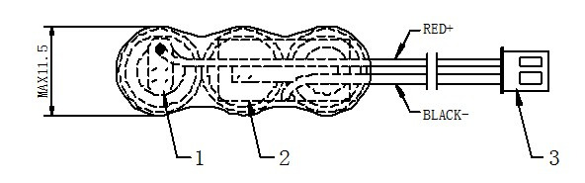
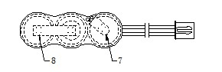

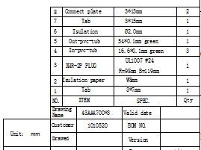
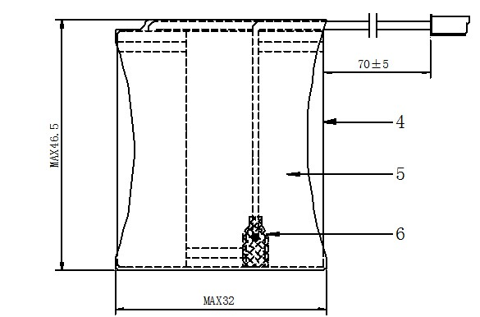

Address: 801-802, Hisee International Commercial Center, Dongbin Road, Nanshan District, Shenzhen, China
地址：深圳市南山区东滨路濠盛商务中心801-802室 Post Code: 518054 邮编：518054
Website: www.ctech.net.cn , www.cheape.cn Alibaba: www.ctech.en.alibaba.com
TEL : (86) 755-82581455 FAX : (86) 755-61624235

