
深圳市驰普电子科技有限公司
CHEAPE TECHNOLOGY INTERNATIONAL LTD

Acknowledgment

Customer Name |  | Chi Pu electronic |  |  |  | Productmodel | D34CELL 4 strings
Delivery date |  | 2012-10-25 |  |  |  | To configure | 8254AAF+4407*8+10Milliohms
Revision |  |  | Page | 03 | Revision |  | A1
Approved |  |  |  | TO examine |  |  | Elaboration
Material Number
Customer confirmation column
Confirmation opinions：

Signature：
Date：
Special Note:
- Customer receive samples promptly after test,the test results will be back to my company FAX:0755-61186524, to facilitate the company to arrange for the project follow-up work, 5 days without any reply,the company for customers to test qualified default,the project ended normally.
- Customer test qualified,please indicate the product customer feedback column names and product code,and stamped signature confirmation,otherwise please test unqualified column indicate te problem,put forward the improvement proposal.
- My company received after customer signed original and enclose the product description functional description,in order to receive orders.

Contents
1 Outline
This specification is suitable 4-serial-cell Lithium ion Battery Protection circuit manufactured by CTECHI TE CO.,LTD
2 Application
- Lithium-ion rechargeable battery packs
- Lithium-ion polymer battery packs

3 Electrical characteristics
Item | Content | Criterion
Over charge Protection | Monomer overcharge protection voltage | 4.35±0.025V
Over charge Protection | Monomer overcharge release voltage | 4.15±0.05V
Charge protection | Rated charging current | ≤4A
Charge protection | Charge current protection | /
Over discharge protection | Single discharge protection voltage | 2.40±0.08V
Over discharge protection | Monomer overdischarge release voltage | 3.0±0.1V
Over discharge protection | Nominal discharge current | ≤8A
Over discharge protection | Discharge current protection | 20±3A
Short protection | There is no short-circuit protection | Yes
Short protection | Protection of short circuit current | /
Short protection | Short circuit protection restoration condition | Disconnect the load
Temperature protection | Thermal protection temperature e | /
Temperature protection | Recovery temperature/time | /
Balanced | Balanced voltage | /
Balanced | Equilibrium current | /
Interior resistance | P+,P-conduction resistance | ≤40mΩ
Current consumption | Self power consumption | ≤35μA
(L*W*H)  Size | 72*28*1.0mm Tolerance：±0.1MM

4 Wiring diagram
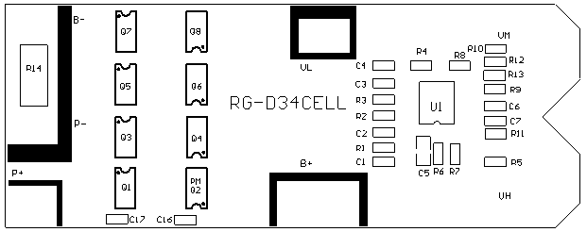
Prot description：
1、B+：Connection fourth section of battery core anode
2、VH：Connection third section of battery core anode
3、VM：Connection second section of battery core anode
4、VL：Connect first battery core anode
5、B-：Connect the negative battery cell section
6、P+：Connecting the output charge / discharge anode
7、P-：Connecting the output charge / discharge cathode

